**Sprint 2 Plan**Product Name: Canvas To Calendar

Team Name: Kirb Squad

Sprint Completion Date: 05/09/2023

Revision Number: 0

Revision Date: N/A

**High Level Goals**

* **Goal**

We want to establish authentication and authorization with Google API, have a functioning web scraping script, and a basic frontend for our Chrome extension.

* **List of User Stories**

As a student, I want the Canvas To Calendar Chrome extension to be able to modify my Google Calendar. [2.1]

**Task 1**: Establish the OAuth 2.0 credentials in Google Cloud to be able to access Google’s APIs.

(~3 hours)

**Task 2**: Implement Chrome’s Identity within the source code to acquire the user authorization token.

(~4 hours)

As a student, I want to allow Canvas To Calendar to have access to all my canvas course information so that my assignments can be injected into my google calendar. [2.2]

**Task 1:** Create an input field for the user to input their personal API key.

(~2 hours)

**Task 2:** Allow for users API key to be saved in Chrome’s Storage so they don't need to reenter the key everytime they want to use the extension.

(~3 hours)

As a student, I want to be able to inject the extracted Canvas course assignments into my google calendar, so that I can easily see my class assignments in the corresponding due dates in my calendar. [2.3]

**Task 1**: Research how to utilize Google Calendar’s API to handle the creation of events.

(~4 hours)

**Task 2**: Implement the Google Calendar’s API within the source code to make requests for new events.

(~4 hours)

**Team Roles**

**Myles Marr**: Product Owner, Developer

**Lucas Michellys**: Developer

**Kaled Barraj**: Scrum Master, Developer

**Utkarsh Pandey**: Developer

**Johan Suresh**: Developer

**Initial Setup**

* **Task Assignment**

**Myles Marr**: [2.2], Task 2

**Lucas Michellys**: [2.2], Task 1

**Kaled Barraj**: [2.1], Task 1 & 2, [2.3], Task 1 & 2

**Utkarsh Pandey**: [2.2], Task 2

**Johan Suresh**: [2.3] Task 1 & 2

* **Burnup Chart**

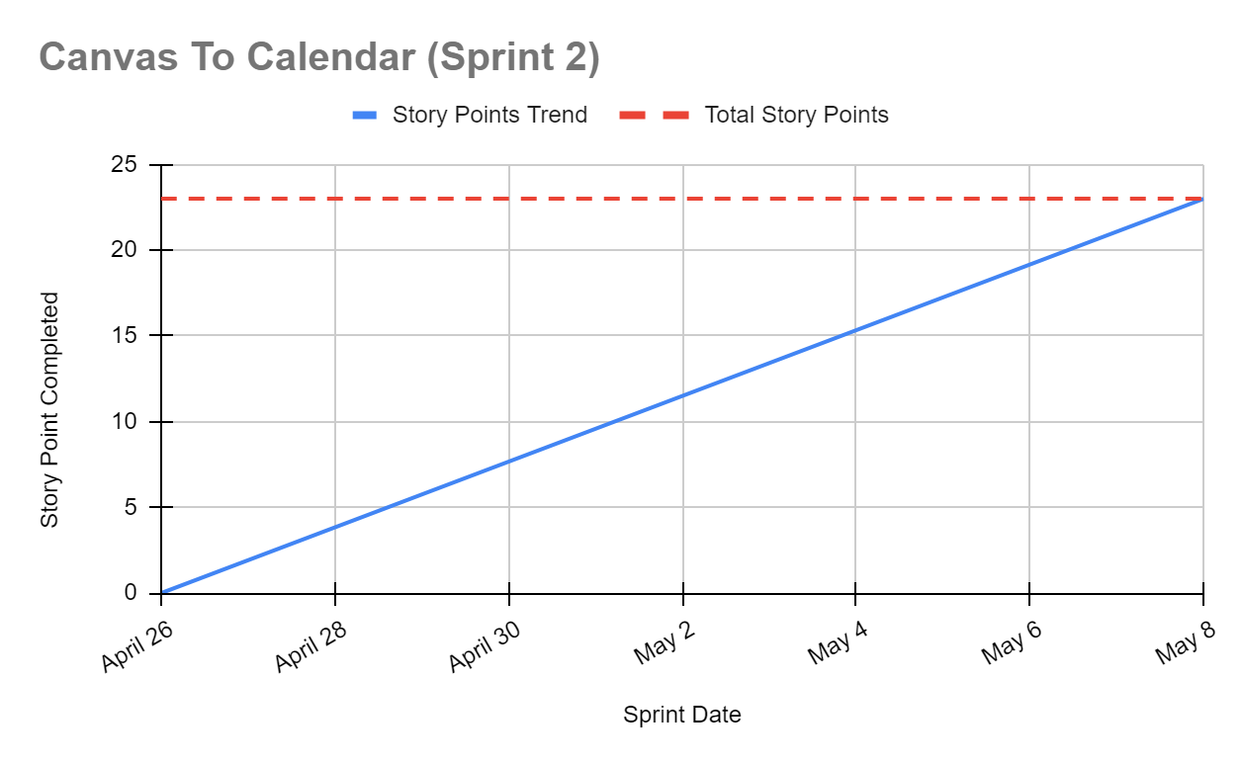

* **Scrum Board**

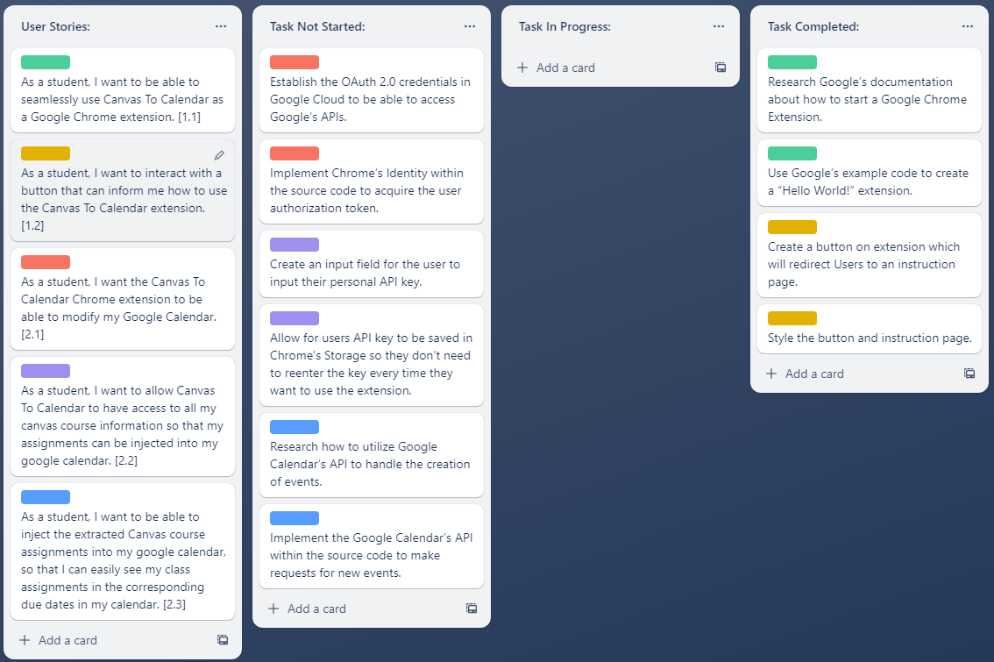

**Scrum Meeting Times**

**Monday:** In the Engineering 1, (9:15 am - 10:15 am)

**Wednesday:** After Zoom with TA, (4:50 pm - 5:20 pm)

**Friday**: Over Discord, (5:00 pm - 5:30 pm)